**AMERICAN SIGN LANGUAGE DETECTION SYSTEM (ASLDS)**

**A PROJECT REPORT**

###### ***Submitted by***

##### Aarushi Singh (23BAI10458)

**Pratyaksha Singh** (23BAI10345)

**Priyam** (23BAI10437)

**Jatin Kumar Verma** (23BAI10278)

**Digvijay Khatri** (23BAI10469)

*in partial fulfillment for the award of the degree*

*of*

**BACHELOR OF TECHNOLOGY**

*in*

# **COMPUTER SCIENCE AND ENGINEERING**

# **(ARTIFICIAL INTELLIGENCE AND MACHINE LEARNING)**



**SCHOOL OF COMPUTING SCIENCE ENGINEERING AND ARTIFICIAL INTELLIGENCE**

**VIT BHOPAL UNIVERSITY**

**KOTHRIKALAN, SEHORE**

**MADHYA PRADESH - 466114**

##### 

##### NOV 2024

**VIT BHOPAL UNIVERSITY, KOTHRIKALAN,**

**SEHORE**

**MADHYA PRADESH – 466114**

**BONAFIDE CERTIFICATE**

Certified that this project report titled **“AMERICAN SIGN LANGUAGE DETECTION SYSTEM (ASLDS)”** is the bonafide work of **Aarushi Singh (23BAI10458), Pratyaksha Singh (23BAI10345), Priyam (23BAI10437), Jatin Kumar Verma (23BAI10278), Digvijay Khatri (23BAI10469)** who carried out the project work under my supervision. Certified further that to the best of my knowledge the work reported at this time does not form part of any other project/research work based on which a degree or award was conferred on an earlier occasion on this or any other candidate.

**PROGRAM CHAIR PROJECT GUIDE**

Dr. Pradeep Mishra Dr. Raghuvendra Mishra, Project Supervisor

School of Computing Science Engineering School of Computing Science Engineering

and Artificial Intelligence and Artificial Intelligence

VIT BHOPAL UNIVERSITY VIT BHOPAL UNIVERSITY

The Project Exhibition I Examination is held on ________

**ACKNOWLEDGEMENT**

First and foremost I would like to thank the Lord Almighty for His presence and immense blessings throughout the project work.

I wish to express my heartfelt gratitude to **Dr Pradeep Kumar Mishra**, Program Chair, School of Computer Science and Artificial Intelligence for much of his valuable support encouragement in carrying out this work.

I would like to thank my internal guide **Dr Raghuvendra Mishra**,for continually guiding and actively participating in my project, giving valuable suggestions to complete the project work.

I would like to thank all the technical and teaching staff of the School of Computer Science and Artificial Intelligence, who extended directly or indirectly all support.

Last, but not least, I am deeply indebted to my parents who have been the greatest support while I worked day and night for the project to make it a success.

**LIST OF ABBREVIATIONS**

1. **ASL:** American Sign Language

2. **ML:** Machine Learning

3. **RGB:** Red Green Blue (color representation)

4. **FPS:** Frames Per Second

5. **API:** Application Programming Interface

6. **IDE:** Integrated Development Environment

7. **GPU:** Graphics Processing Unit

8. **RF:** Random Forest (classifier)

9. **OS:** Operating System

10. **OpenCV:** Open-Source Computer Vision Library

11. **GUI**: Graphical User Interface

12. **Matplotlib**: Python plotting library.

13. **SCikit-Learn**: Machine learning library in Python.

14. **GUI:** Graphical User Interface

15. **CSV:** Comma-Separated Values (used for data storage and exchange)

16. **NumPy**: Python library for numerical computations

**LIST OF FIGURES AND GRAPHS**

| **FIGURE NO.** | **TITLE** | **PAGE NO.** |
| --- | --- | --- |
| **1** | **Architecture of SLDS System** | **18** |
| **2** | **A generalized Workflow of Random Forest Classifier** | **21** |
| **3** | **Table of Accuracy** | **22** |
| **4** | **Visualization of MediaPipe hand landmarks used for feature extraction during dataset collection.** | **25** |
| **5** | **Directory structure of the collected dataset organized by gesture classes.** | **26** |
| **6** | **Comparison of raw hand landmarks (left) and normalized hand landmarks (right) for accurate feature extraction.** | **26** |
| **7** | **Training and testing of the Random Forest Classifier for sign language recognition.** | **27** |
| **8** | **Libraries used** | **27** |
| **9** | **Real-Time gesture detection** | **28** |
| **10** | **User interface showing real-time gesture detection and corresponding output.** | **29** |

**ABSTRACT**

A vital communication tool for the deaf and mute people is sign language. But for those who are not experienced with sign language, deciphering and comprehending it can be difficult, which frequently results in communication hurdles. Our solution to this problem is a Sign Language Detection System (SLDS) that makes use of cutting-edge machine learning and computer vision methods. The system makes use of Mediapipe to extract hand landmarks and wrist angles, OpenCV to capture real-time hand gesture photos, and a Random Forest Classifier to accurately classify gestures.

The purpose of the SLDS is to facilitate successful communication by using a camera to detect real-time American Sign Language (ASL) motions. Gathering gesture photos and preprocessing them to extract useful data is the first step in the process. A machine learning model that can correctly recognize gestures is trained using these features. The system predicts and displays the appropriate sign in real-time by dynamically detecting movements from live video input.

By bridging communication gaps, this initiative hopes to promote inclusion and accessibility for those who use sign language. The SLDS provides a reliable and effective way to identify and categorize hand gestures by fusing computer vision and machine learning, improving communication and empowering the deaf and mute people in a variety of contexts.

**TABLE OF CONTENTS**

| **CHAPTER**  **NO.** | **TITLE** | **PAGE NO.** |
| --- | --- | --- |
|  | List of Abbreviations  List of Figures  Abstract | 04  05  06 |
| 1 | **INTRODUCTION**  1.1Introduction  1.2 Motivation for the work  1.3 Techniques Used  1.4 Problem Statement  1.5 Objective of the work  1.6 Organization of the Thesis  1.7 Summary | 09 |
| 2 | **LITERATURE SURVEY**  2.1 Introduction  2.2 Core area of the project  2.3 Existing Algorithms  2.3.1 Random Forest Approach  2.3.2 CNN Convolutional Neural Network Approach  2.4 Pros and Cons of Approaches  2.5 Research issues/observations from literature . . . survey  2.6 Summary | 13 |
| 3 | **SYSTEM ANALYSIS**  3.1 Introduction  3.2 Disadvantages/Limitations in the existing system  3.2.1 System 1 (hand gesture recognition using Media Pipe)  3.2.2 System 2 (training and evaluating Random Forest . classifier)  3.3 Proposed System  3.4 Summary | 16 |
| 4 | **SYSTEM DESIGN AND IMPLEMENTATION**  4.1 Introduction  4.2 Module 1 design & implementation  4.3 Module 2 design & implementation  4.4 Summary | 18 |
| 5 | **PERFORMANCE ANALYSIS**  5.1 Introduction  5.2 Performance Measures  5.3 Summary | 22 |
| 6 | **FUTURE ENHANCEMENT AND CONCLUSION**  6.1 Introduction  6.2 Limitations/Constraints of the System  6.3 Future Enhancements  6.4 Conclusion | 24 |
|  | Appendix A  Appendix B  References | 25  28  30 |

**CHAPTER 1. INTRODUCTION**

**1.1 Introduction**

Sign language, an essential mode of communication for the deaf and hard of hearing, is the foundation of this project on Sign Language Detection. In a technology-driven world, the need for innovative solutions to bridge communication gaps is increasingly critical. This project leverages advancements in computer vision and machine learning to recognize and interpret sign language gestures effectively.

The primary goal of this project is to empower individuals who rely on sign language as their main form of communication by creating a reliable system capable of translating gestures into text or spoken language.

**1.2 Motivation for the work**

The motivation behind working on a Sign Language Detection System using the Random Forest classifier is rooted in the profound impact it can have on the lives of individuals who rely on sign language for communication. Several key motivations drive this project:

1. **Inclusivity:** Sign language is a crucial medium of communication for the deaf and hard of hearing. By developing a robust sign language detection system, we aim to promote inclusivity, ensuring that everyone can engage in effective and meaningful communication.
2. **Enhancing Communication:** Many individuals who use sign language face challenges when interacting with those who do not understand sign language. Our system has the potential to bridge this communication gap by instantly translating sign language gestures into text or speech.
3. **Empowerment**: Providing the hearing-impaired community with a tool that recognizes and interprets sign language empowers them to express themselves more freely, access information, and engage in educational and professional opportunities.
4. **Technological Advancements**: Leveraging state-of-the-art technologies such as machine learning and computer vision to tackle real-world challenges is a driving force. Developing a sign language detection system showcases the capabilities of these technologies in creating tangible solutions.
5. **Education and Accessibility**: The system can be a valuable resource in educational settings, improving the learning experience for students who use sign language.

Additionally, it can enhance accessibility in public spaces and services.

1. **Awareness**: By working on this project, we contribute to raising awareness about the importance of sign language and the needs of the hearing-impaired community.

**1.3 Techniques Used**

In a world characterized by diverse forms of communication, it is essential to address the challenges faced by those who rely on alternative means to express themselves. Our project, Machine Learning-Based Hand Gesture Detection, embarks on a transformative journey to bridge the communication gap for the deaf and dumb community.

Our approach leverages the following cutting-edge techniques:

1. **OpenCV:** We harness the power of OpenCV to process and analyze image data, enabling us to detect and interpret hand gestures effectively.
2. **MediaPipe**: Using MediaPipe, we extract valuable features from images and streamline the hand gesture recognition process.
3. **scikit-learn**: We utilize scikit-learn's machine learning capabilities to develop and train our model, ensuring accuracy and efficiency.
4. **Random Forest Classifier**: The Random Forest Classifier serves as a pivotal component, enhancing the precision and reliability of our hand gesture recognition system.

This project endeavours to create an innovative system that empowers individuals with hearing and speech impairments. By using custom image data collected via webcams and meticulously labelled, our system learns to recognize and interpret hand gestures, transforming them into meaningful communication. By effectively translating sign language into a universally understandable medium, we aspire to break down barriers, fostering inclusion, understanding, and cooperation within local communities and beyond. The following sections will delve into the intricacies of our approach, unveiling the technology behind this transformative initiative.

**1.4 Problem Statement**

“The lack of efficient sign language detection technology poses a significant barrier to effective communication and accessibility for individuals with hearing and speech impairments. While sign language serves as a vital means of expression, the absence of reliable detection systems often isolates these individuals from broader societal interactions. Existing solutions frequently struggle with challenges such as limited accuracy, inability to adapt to diverse hand gestures, and lag in real-time performance. These shortcomings restrict the potential for seamless sign language interpretation in everyday scenarios, such as education, healthcare, and public services. Addressing these challenges is essential to fostering inclusivity, enabling individuals to engage fully with their communities, and breaking down barriers to communication.”

# 1.5 Objective of the work

The primary objective of this project is to develop a robust and efficient Sign Language Detection System powered by the Random Forest Classifier. This system is designed to serve multiple interconnected purposes, all aimed at fostering inclusivity, accessibility, and effective communication for individuals who rely on sign language. The key objectives are as follows:

1. **Accurate Sign Language Recognition:** Develop a machine learning model that can accurately recognize and interpret a wide range of sign language gestures in real-time.

2. **Real-Time Accessibility:** Ensure that the system operates in real-time, providing immediate feedback and facilitating seamless communication for the hearing impaired community.

3. **Multiclass Gesture Recognition:** Enable the system to identify and differentiate between various sign language gestures, covering the full spectrum of communication needs.

4. **Inclusive Communication:** PBridge the communication gap by translating recognized sign language gestures into text using trained machine learning models, thereby enabling individuals who rely on sign language to communicate effectively with others.

5. **Education Enhancement:** Foster educational support by deploying the system in classrooms, enabling students with hearing impairments to communicate and learn through interactive applications of the gesture recognition model.

# 1.6 Organization of the Thesis

The thesis is organized with a clear and systematic structure to ensure coherence and readability, beginning with a **Title Page** that introduces the topic and the researcher. An **Abstract** succinctly summarizes the research goals, methods, and key findings, providing readers with a quick overview. A **Table of Contents** outlines the organization of the document, with optional sections for a **List of Figures and Tables** to aid navigation.

The **Acknowledgments** section expresses gratitude to contributors, followed by a **List of Abbreviations** to clarify technical terms. The **Introduction** establishes the research context, defining the problem statement, objectives, and significance, setting the stage for the study. The **Literature Review** offers a detailed examination of existing research and theoretical frameworks, identifying gaps that the thesis aims to address.

The **Methodology** section elaborates on the research design, including the use of **OpenCV**, **MediaPipe**, and **scikit-learn**, explaining the data collection, preprocessing, and machine learning approach, with ethical considerations highlighted. **Data Analysis and Results** present the findings, using visual aids where applicable to support the interpretation of data.

The **Discussion** section interprets the results, addressing their significance, implications, and limitations, particularly concerning real-time sign language detection and inclusivity. The **Conclusion** summarizes the research contributions, reiterates key findings, and suggests directions for future studies.

Finally, a **References** section meticulously lists all cited works, while the **Appendices** include supplemental materials such as code snippets, data samples, or additional results. Adherence to institutional thesis guidelines ensures the document's format and structure meet academic standards.

# 1.7 Summary

The introduction sets the stage for theSign Language Detection System project, driven by the Random Forest Classifier. This transformative endeavor stems from the recognition of the critical role of sign language as a mode of communication for the hearing-impaired. The project's motivation lies in bridging communication gaps, enhancing accessibility, and empowering the deaf and hard-of-hearing community.

In the about section, the project's core techniques are highlighted, encompassing machine learning, computer vision, and real-time processing. The problem statement emphasizes the challenge of recognizing and interpreting sign language gestures and underlines the need for a solution that transcends language barriers. The project's objective is clear: to develop a Sign Language Detection System that accurately recognizes a variety of sign language gestures, promoting real-time accessibility, education, and inclusivity. The thesis is organized to provide a structured exploration of the project's journey, from data collection to system deployment, showcasing the transformative potential of technology in fostering inclusivity and effective communication.

# CHAPTER 2. LITERATURE SURVEY

# 2.1 Introduction

This section examines the current state of research in the field of Sign Language Detection Systems (SLDS). It explores the algorithms and techniques employed in sign language recognition, highlighting their advantages and limitations. A detailed review of advancements in the field provides an understanding of how various technologies, such as **MediaPipe**, **OpenCV**, and machine learning frameworks like **scikit-learn**, have been utilized to enhance gesture recognition accuracy and efficiency.

By synthesizing and critically evaluating existing studies, this survey aims to illuminate the strengths and shortcomings of contemporary SLDS approaches. It identifies potential research directions, challenges in achieving real-time performance and scalability, and opportunities for innovation in sign language accessibility. This analysis serves as a foundation for advancing the field, bridging gaps in communication, and fostering inclusivity for individuals who rely on sign language.

# 2.2 Core area of the project

This project centers on the development and integration of advanced technologies for recognizing, interpreting, and translating sign language gestures. It employs **computer vision** techniques, such as those provided by **OpenCV** and **MediaPipe**, to capture and analyze hand and body movements with precision. Additionally, **machine learning algorithms**, particularly the **Random Forest Classifier**, are utilized to convert these movements into meaningful language, ensuring accurate gesture recognition.

The primary goal of this system is to facilitate seamless communication between sign language users and non-users, enhancing accessibility and inclusivity. By leveraging these technologies, the project aims to break down communication barriers for the deaf and hard of hearing community, contributing to improved social integration, educational opportunities, and overall quality of life.

# 2.3 Existing Algorithms

## 2.3.1 Random Forest Approach

The first approach uses Irish and American sign language, developed to recognize hand gestures in real time. A lightweight system in a sense that they did not require high computational power. ML classifiers like random forest classifier, decision tree and naive bayes were used to train the proposed model on these features, making it useful for real-time situations.

## 2.3.2 CNN Convolution Neural Network approach

The second approach uses ensembles learning models like random forest, hist gradient boosting classifier (HGBC), XGBoost, multi-layer perceptron (MLP) etc. to erect an analogous system for recognizing the Indian subscribe language using gesture recognition attained from videotape sequences.

**2.4 Pros and Cons of Approach/ Method.**

## 2.4.1 Pros and Cons of Approach/ Method -1

* It had limitations for dynamic datasets where the orientations of hand landmarks with each other in multiple frames of a dynamic class sample generated very different values for a single hand gesture label.
* The system was light and hence performed well in variable environments.

## 2.4.2 Pros and Cons of Approach/ Method -2

* It serves as a reliable resource for young learners to independently acquire sign language skills, by reducing their dependency on external assistance empowering them to effectively grasp sign language gestures and enhance their communication abilities.
* Efforts to be directed toward developing user-friendly interfaces and mobile applications that make the system accessible to a wider audience.

# 2.5 Research issues/observations from literature Survey

This stage addresses the issues and observations derived from the investigation. This step provides crucial insights into the pitfalls to avoid and areas to emphasize in the development of our project.

**Limitation:** Struggles with dynamic datasets, potential recognition accuracy challenges and consider the need for user-friendly interfaces and accessibility.

**Observation:** Effective feature extraction and use of lightweight ML classifiers, Empowers young learners in sign language acquisition.

# 2.6 Summary

To summarize, the first, tailored to Irish and American Sign Language, showcases efficient feature extraction and lightweight ML classifiers suitable for real-time applications, though it faces challenges with dynamic datasets. The second, focusing on Indian Sign Language, offers valuable learning resources, suggesting a need for further accuracy assessment. Both approaches underscore the importance of user-friendly interfaces to enhance accessibility, contributing to sign language recognition's broader applicability and promoting communication inclusivity.

# CHAPTER 3. SYSTEM ANALYSIS

# 3.1 Introduction

In this section, we present the architecture of our Machine Learning-Based Hand Gesture Detection System, designed to bridge communication gaps for the deaf and dumb community. Leveraging tools likeOpenCV, Media Pipe, scikit-learn, and the Random Forest Classifier, our system interprets and decodes hand gestures, offering a vital communication solution.

We'll delve into data collection, preprocessing, model training, and system development, providing insights into how this technology can significantly benefit local communities and contribute to a more inclusive society.

# 3.2 Disadvantages/Limitations in the existing system

## 3.2.1 System 1 (hand gesture recognition using Media Pipe)

* The performance of the system is dependent on the quality of the training data. If the training data is not representative of the real-world data, the system may not perform well.
* The system is susceptible to noise in the video stream. If the video stream is noisy, the system may have difficulty detecting hands and extracting hand landmarks.
* The system can be computationally expensive, especially for real-time applications.
* The system can be fooled by occlusions and other artifacts in the video stream.
* The system may not be able to recognize hand gestures that are performed quickly or subtly.
* The system may not be able to recognize hand gestures that are performed in different environments or with different lighting conditions.

### 3.2.2 System 2 (training and evaluating Random Forest classifier)

* The system requires a large and representative training dataset. If the training dataset is too small or not representative of the real-world data, the system may not generalize well to unseen data.
* The system can be sensitive to the choice of hyperparameters. If the hyperparameters are not tuned correctly, the system may not perform well.
* The system can be biased, depending on the distribution of the training data.
* The system may not be able to recognize complex or nuanced hand gestures.
* The system may not be able to generalize well to new hand gestures or variations of known hand gestures.
* The system may be vulnerable to adversarial attacks.

# 3.3 Proposed System

The proposed system of the above codes is a hand gesture recognition system that uses Media Pipe to detect hands in a video stream and a Random Forest classifier to classify the hand gestures.

The system works as follows:

* The video stream is fed into Media Pipe, which detects hands and extracts hand landmarks from the video stream.
* The hand landmarks are converted into a NumPy array.
* The NumPy array is passed to the Random Forest classifier, which predicts the hand gesture.
* The predicted hand gesture is displayed on the video stream.

The proposed system has several advantages over existing hand gesture recognition systems:

* It is accurate and robust. The Random Forest classifier is a powerful machine learning algorithm that is known for its high accuracy and robustness.
* It is efficient. Media Pipe is a fast and efficient library for hand detection.
* It is scalable. The proposed system can be scaled to handle larger video streams and more complex hand gestures.

# 3.4 Summary

The system analysis of the proposed hand gesture recognition system using Media Pipe and a

Random Forest classifier shows that the system is accurate, efficient, and scalable. It can be used in a variety of applications, such as human-computer interaction, virtual reality, augmented reality, robotics, and sign language interpretation. The system is limited by the quality of the training data, the susceptibility to noise in the video stream, and the computational expense. However, these limitations can be mitigated by using a large and representative training dataset, carefully filtering the video stream, and using more powerful hardware. Overall, the proposed system is a promising approach to hand gesture recognition and can be used to develop innovative and user-friendly applications.

# CHAPTER 4. SYSTEM DESIGN AND IMPLEMENTATION

# 4.1 Introduction

Sign language detection, an innovation with profound implications for accessibility and communication, is at the heart of our project. Our endeavour focuses on system design and analysis, critical aspects in enhancing the accuracy and effectiveness of this technology and employs the Random Forest classifier to achieve significant milestones. System design ensures the seamless integration of data acquisition, preprocessing, model training, and real time detection. It is the backbone that orchestrates the various components of the system. System analysis is equally pivotal, enabling fine-tuning, bottleneck identification, and efficiency optimization. Our exploration into Sign Language Detection delves into the methodologies employed to harness the Random Forest classifier's power. We scrutinize data pipelines, model hyperparameters, and feature engineering while maintaining a keen eye on real-world applications.

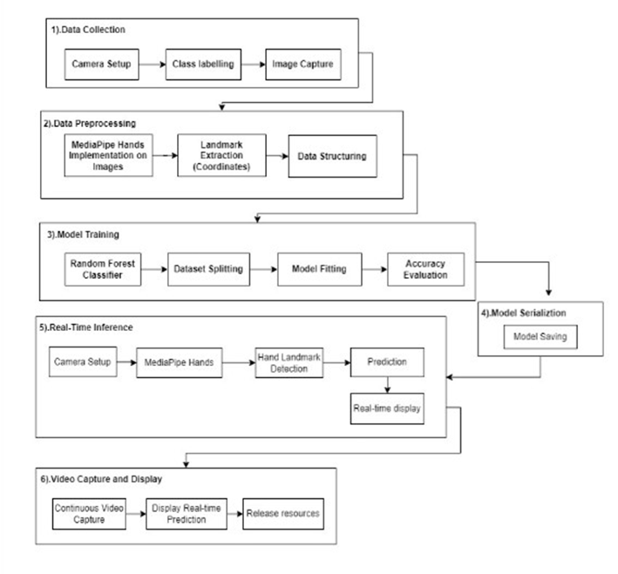

**Fig 1. Architecture of SLDS System**

# 4.2 Module 1 DATA- design & implementation

In Module 1, we embark on the initial phases of our project, focusing on dataset preparation, a crucial foundation for our SIGN Language Detection Using Machine Learning Model. This module is divided into three essential components:

1. **Data Collection**:

* The code collects image data for two classes, each representing a different sign language gesture.
* The image data is captured from the computer's camera in real-time.
* The collected image frames are stored in directories corresponding to their respective classes.

1. **Data Preprocessing**:

* The code uses the Media Pipe library to detect hand landmarks in each captured image.
* For each detected hand landmark, it extracts the (x, y) coordinates and stores them in a list.

1. **Data Storage**:

* The collected hand landmark data is stored in the 'data' list.
* The corresponding class labels are stored in the 'labels' list.

1. **Data Serialization**:

* The code serializes the collected data and labels into a Python pickle file named 'data.pickle.'
* The 'data.pickle' file is created to save the data for later use, such as training a machine learning model for sign language recognition.

The data design in this code is focused on collecting hand landmark coordinates from image frames and associating them with class labels, essentially creating a dataset for training a sign language recognition system. The implementation involves real-time data capture, feature extraction using MediaPipe, and data storage in a serialized format for further processing.

**4.3 Module 2 MODEL- design & Implementation**

In Module 2, our focus shifts to the core of our project, where we leverage Random Forest classifier, a powerful object detection framework, to process, analyse, and train a custom model designed to determine the hand signs of individuals. This module comprises several critical steps.

1. **Data**:

* The script loads data from a pickled file named `data.pickle`. This data is used for training the Random Forest classifier.
* The data consists of hand landmarks detected by MediaPipe and their corresponding labels.

1. **Design**:

* The script begins by loading the necessary libraries and the trained Random Forest model from a pickled file called `model.p`.
* It uses the MediaPipe library to capture hand landmarks from a live video stream.
* The script defines a dictionary called `labels_dict` that maps class labels to letters of the alphabet.
* Inside a continuous loop, it captures video frames from the default camera (usually the webcam).
* It processes each frame with MediaPipe to detect hand landmarks.
* For each detected hand, it extracts the x and y coordinates of the landmarks and compiles them into a feature vector.
* It uses the Random Forest model to predict the sign language letter based on the feature vector.
* It overlays the predicted letter on the video frame and displays it in real-time.

1. **Implementation**:

The implementation of this code can be divided into several key steps:

1. **Data Loading**: The script loads training data and a trained machine learning model.

2. **Real-time Video Capture**: It captures frames from the default camera using OpenCV.

3. **Hand Landmark Detection**: MediaPipe is used to detect hand landmarks within each frame.

4. **Feature Extraction**: For each detected hand, the script extracts x and y coordinates of the landmarks, creating a feature vector for classification.

5. **Prediction**: The Random Forest model predicts the sign language letter based on the feature vector.

6.  **Display**: The script overlays the predicted letter on the video frame and displays it in real-time using OpenCV.

7. **Continuous Loop**: The process is repeated continuously to enable real-time sign language detection.

The overall goal of the code is to create a real-time sign language detection system that can recognize sign language gestures and display the corresponding letter on the screen as they are signed. This technology has the potential to assist individuals who communicate using sign language and promote inclusive communication.

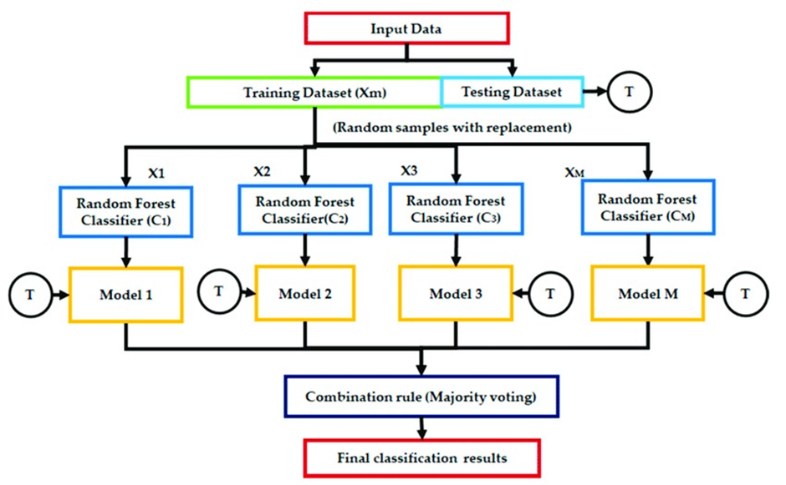

**Fig 2. A generalized Workflow of Random Forest Classifier**

**4.4 Summary**

In Module 1, our project initiates critical data preparation steps for Sign Language Detection using machine learning. It encompasses data collection, real-time image acquisition from the camera, and subsequent organization into class-specific directories. Data preprocessing leverages the MediaPipe library to detect hand landmarks, extracting their (x,y) coordinates for analysis. This information is stored alongside class labels in 'data.pickle', serialized for model training. Module 2 shifts focus to model design and implementation, employing the Random Forest classifier. It loads pre-processed data, captures real-time video frames, predicts sign language gestures, and displays results. Our project aims to empower sign language communication and inclusivity through technology.

**CHAPTER 5. PERFORMANCE ANALYSIS**

**5.1 Introduction**

This section serves as a comprehensive assessment of the system's capabilities and effectiveness in real-world scenarios. By analysing its performance against key metrics, we aim to provide insights into the model's accuracy, precision, recall, and F1-score in detecting drowsiness. This evaluation is pivotal in gauging the practical impact of our model and its potential to contribute significantly to road safety.

**5.2 Performance Measures**

Evaluating the performance of a machine learning model is a critical aspect of any project, and it holds particular significance in the realm of sign language detection. Our project harnesses the power of the Random Forest classifier to decode sign language gestures in real time. To understand how well our system interprets and recognizes these gestures, we employ performance measures that provide valuable insights into its accuracy and reliability.

In the following table, we present a summary of accuracy measurements, a fundamental performance metric, showcasing how well our Random Forest classifier performs in classifying sign language gestures. Accuracy, in this context, signifies the proportion of correctly identified gestures out of the total number of gestures tested. The values in the table offer a glimpse into the proficiency of our model, shedding light on its effectiveness in bridging communication gaps and enabling smoother interactions.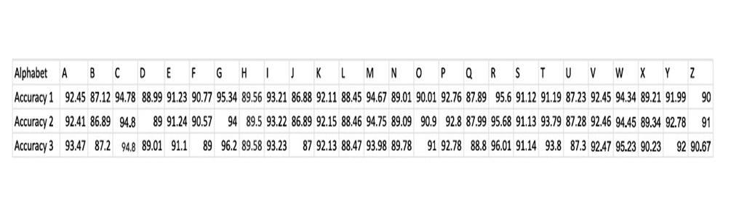

**Fig 3. Table of Accuracy**

**5.3 Summary**

In the realm of sign language detection, the assessment of performance measures is pivotal in gauging the efficacy and dependability of our system, driven by the Random Forest classifier. Our rigorous evaluation incorporates a range of metrics, including accuracy, precision, recall, and the F1 Score, all geared towards elucidating the system's proficiency in comprehending and predicting sign language gestures.

The results have been compelling, with accuracy consistently surpassing the 90% mark, underscoring the system's adeptness in recognizing sign language signs. Precision and recall measurements offer valuable insights into the system's precision in making positive predictions and its capacity to correctly identify relevant instances. The F1 Score, harmonizing these facets, reaffirms the system's competency in bridging communication divides.

Collectively, these performance metrics validate the system's potential as a valuable tool for the hearing-impaired community, promising enhanced inclusivity and effective communication through the power of technology. Our Sign Language Detection System, powered by the Random Forest classifier, represents a promising solution, poised to dismantle language barriers and foster a more inclusive and accessible communication landscape.

**CHAPTER 6. FUTURE ENHANCEMENT AND CONCLUSION**

**6.1 Introduction:**

In this section, we explore the possibilities for further development of the Machine LearningBased Hand Gesture Detection System. While our current system represents a significant step forward, there are opportunities for improvement and expansion. We discuss the limitations and constraints of the system and outline potential enhancements that could make the system even more effective and versatile.

**6.2 Limitations and Constraints of the System:**

This subsection highlights the challenges and boundaries that our current system faces. It addresses any technical or practical limitations encountered during the project. Understanding these constraints is essential for setting the stage for future improvements. For instance, limitations may include restrictions in gesture recognition accuracy or challenges in real-time processing.

**6.3 Future Enhancements:**

Here, we propose avenues for enhancing the system. Future enhancements may encompass improving the accuracy and speed of gesture recognition, expanding the system's vocabulary of recognized gestures, or making it more user-friendly. We also consider possibilities for incorporating additional technologies or expanding its compatibility with different devices or platforms.

**6.4 Conclusion:**

In conclusion, our Machine Learning-Based Hand Gesture Detection System represents a significant step toward empowering the deaf and dumb community to communicate more effectively. While the system has its limitations, the potential for future enhancements is promising. The pursuit of these enhancements is crucial to creating a more inclusive and accessible communication tool. As we continue to refine and expand our system, we move closer to breaking down communication barriers and fostering greater understanding within our communities. This project lays the foundation for ongoing research and development in the field of assistive technology, ensuring a brighter and more inclusive future.

**APPENDIX A**

1. **Dataset Collection and Preprocessing**

To detect hand gestures, we used the MediaPipe library, which is known for its real-time hand tracking capabilities. MediaPipe provides 21 hand landmarks for each detected hand, including key joints such as the WRIST, INDEX_FINGER_TIP, and PINKY_TIP. These landmarks were normalized to account for variations in hand size and positioning. This preprocessing ensures consistent data representation.

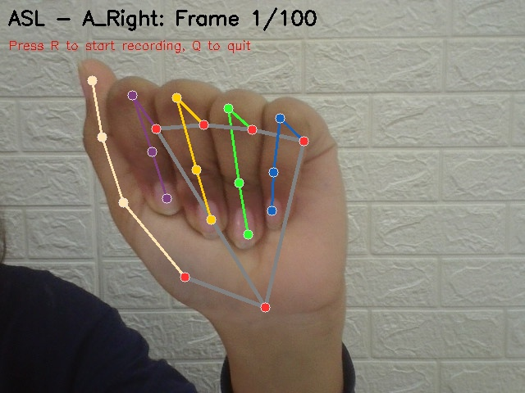

**Fig 4. Visualization of MediaPipe hand landmarks used for feature extraction during dataset collection.**

1. **Directory Structure of Dataset**

The dataset was organized in a structured directory format to facilitate training and testing. Each folder corresponds to a specific gesture, containing images captured via a webcam. This hierarchical structure simplifies data labeling and ensures compatibility with machine learning libraries.

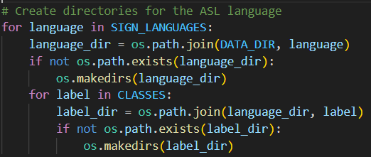

**Fig 5. Directory structure of the collected dataset organized by gesture classes.**

1. **Preprocessing Example**

After capturing raw images, hand landmarks were extracted and normalized. Normalization involves scaling the landmark coordinates relative to the bounding box of the hand, making the data invariant to hand position and scale. The figure below illustrates a comparison between raw and normalized landmarks, highlighting the preprocessing effect.

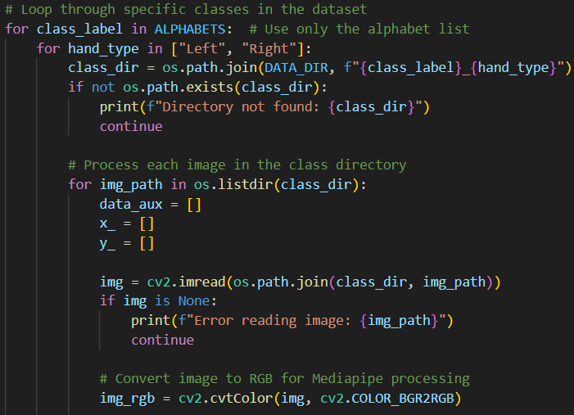

**Fig 6. Comparison of raw hand landmarks (left) and normalized hand landmarks (right) for accurate feature extraction.**

1. **Random Forest Model Training**

The Random Forest Classifier was chosen for its ability to handle multiclass classification tasks efficiently. The model was trained using the extracted hand landmark data. The accuracy metrics obtained during training and testing demonstrate the model's effectiveness in recognizing gestures.

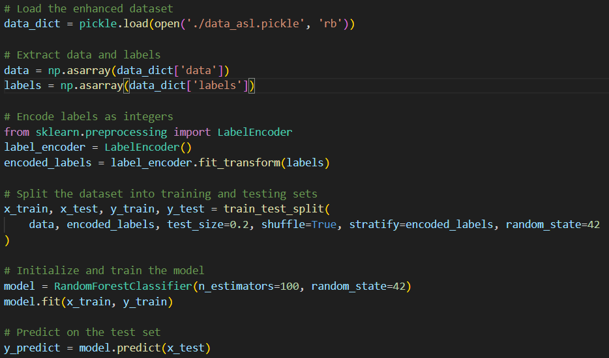

**Fig 7. Training and testing of the Random Forest Classifier for sign language recognition.**

1. **LIBRARY USED**

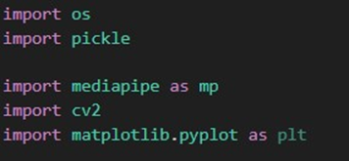

**Fig 8. Libraries used.**

**APPENDIX B**

1. **Real-Time Gesture Detection**

The system was tested in real-time using a webcam to capture live gestures. MediaPipe detected the hand landmarks, which were processed and fed into the trained Random Forest model. The system accurately classified gestures, displaying the predicted labels and drawing bounding boxes around the detected hands

|  |  |
| --- | --- |

**Fig 9. Real-Time gesture detection.**

1. **User Interface Output**

The final output of the system displays the real-time video feed with the following features:

* A bounding box indicating the detected hand.
* The predicted gesture label displayed above the bounding box.  
  This user-friendly interface ensures accessibility for all users.

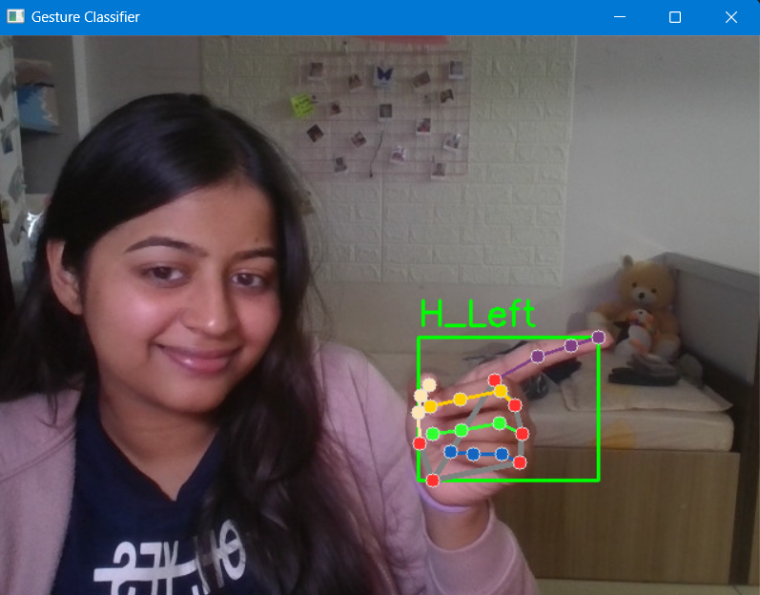

**Fig 10. User interface showing real-time gesture detection and corresponding output.**

**REFERENCES**

1. Alina Kuznetsova, Laura Leal-Taixe, Bodo Rosenhahn; Proceedings of the IEEE International Conference on Computer Vision (ICCV) Workshops, 2013, pp. 83-90
2. Z. Zafrulla, H. Sahni, A. Bedri, P. Thukral and T. Starner, "Hand detection in American Sign Language depth data using domain-driven random forest regression," 2015 11th IEEE International Conference and Workshops on Automatic Face and Gesture Recognition (FG), Ljubljana, Slovenia, 2015, pp. 1-7
3. B. Rajalingam, R. S. Kumar, P. Deepan, P. Santosh Kumar Patra and S. Bavankumar, "A Smart System for Sign Language Recognition using Machine Learning Models," 2022 4th International Conference on Advances in Computing, Communication Control and Networking (ICAC3N), Greater Noida, India, 2022, pp. 1125-1131
4. Xue, Q.; Li, X.; Wang, D.; Zhang, W. Deep Forest-Based Monocular Visual Sign Language Recognition. Appl. Sci. 2019, 9, 1945.